ARMY SAILING ASSOCIATION
GET ON THE WATER IN 2027
Army Watersports Centre
Thorney Island • Baker Barracks • Chichester Harbour
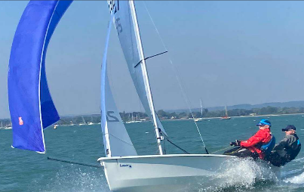
LEARN A SPORT. BRING YOUR UNIT.
Dinghy sailing • Wing foiling • Windsurfing
Kitesurfing • Powerboating
Dinghy sailing, wing foiling & windsurfing: £60 / two days
Kitesurfing: £200 / four days • Powerboating: £229
Unit activity days: £30 per person per day – plus kit hire £15 per person per day
On-site basic accommodation included with courses and activity days. Individuals and unit groups welcome; weekend capacity available for Reserve units.
BECOME A SEASONAL INSTRUCTOR
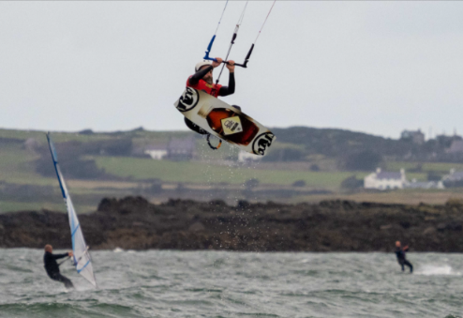
Full season: 1 March – 19 November 2027
Short season: 1 March – 29 May 2027
Gain instructor qualifications, develop leadership skills and support watersports training. No previous experience needed for some pathways; kitesurfing and powerboat instructor routes have prerequisites. Accommodation provided at no cost.
Apply through your chain of command. Short-season staff are requested to return to deliver at least two courses during the 2027 season.
Who can attend? ASA members, including serving Army personnel and Reservists. Cadets must attend as a formed group. Ask the ASA office about membership.

BOOK A COURSE • ASK ABOUT INSTRUCTOR ROLES
Nik Barnes — Centre Manager
AISTC@britisharmysport.com • 07832279614
ASA office: sailing@britisharmysport.com • 07586550581
