EXERCISE MEDITERRANEAN UBIQUE Leg 10 | 8 – 22 AUG 26 | PORTUGAL AND NW SPAIN

Introduction

1. Overview of the exercise:

a. EXERCISE MEDITERRANEAN UBIQUE Leg 10: 8 – 22 Aug 26: PORTUGAL and NW SPAIN – Conducting adventurous sail training along the Atlantic coast of the Iberian Peninsula from VILLAMOURA to A CORUNA with a crew change mid-way at PORTO, a distance of 574 nautical miles (1063 km) including 30 night hours (3 overnight passages). 11 SPs took part in the exercise with various levels of experience. The exercise was assessed as low-medium risk, and therefore the risk management was authorised by CO 100 Regt RA.

b. The unit involved in the exercise. 100 Regiment Royal Artillery, Woolwich – with 2 SP from 255 Bty and 9 SP from the All Arms Staff Pool.

c. Countries visited and general area of exercise. Atlantic coast of Portugal and NW Spain.

d. Overview of what the expedition achieved:
- 2 SP who had little or no prior sailing experience gained valuable knowledge about sailing, teamwork and living on board a yacht. Unfortunately it was not possible to grant them the Royal Yacht Association (RYA) Competent Crew qualification as there was nobody on board qualified to do the assessment.
- 5 Competent Crew/Day Skippers gained valuable mileage and night hours for their log books in preparation for the next level qualification
- 2 SP with Coastal Skipper and Yachtmaster (Coastal) respectively skippered day and night legs in excess of 60 nautical miles, which are prerequisite activities prior to qualifying for the next level qualification
- The long passages during which a watch system was established, close confinement living conditions and adapting to living and working under sailing conditions with constant rolling and pitching, as well as the frequent challenges of coping with seasickness and risk-assessing/mitigating the threat of orca interactions all created a challenging and arduous environment perfect for developing leadership and resilience, stretching participants, demanding selfless commitment and developing cohesion and teamwork.

e. Expedition leader's details: Lt Col Jon McCleery RA, SO1 LO BCDA, 100 Regt RA, Woolwich, London. Tel – 07748649354.

Expedition Members – Nominal Roll

2. Expedition participants:

Ser | Rank | Name | Unit | Dates | Remarks
1 | Maj | Rob GILES | AASP, 100 Regt RA | 8-22 Aug 26 | Skipper / Yachtmaster (YM) Coastal / First Aid
2 | Capt | Josh MOULTRIE | AASP, 100 Regt RA | 8-22 Aug 26 | Novice / Purser
3 | Lt Col | James EDWARDS | AASP, 100 Regt RA | 8-16 Aug 26 | First mate / YM Offshore / First Aid
4 | Maj | Charlie CALDERWOOD | AASP, 100 Regt RA | 8-16 Aug 26 | Comp crew
5 | Gnr | Lloyd PARSONS | 255 Bty, 100 Regt RA | 8-16 Aug 26 | Comp crew / Media officer
6 | Maj | Owen BROWN | AASP, 100 Regt RA | 8-16 Aug 26 | Comp crew
7 | Capt | Tim BENSON | 255 Bty, 100 Regt RA | 8-16 Aug 26 | Novice crew / First Aid
8 | Lt Col | Jonathan McCLEERY | AASP, 100 Regt RA | 16-22 Aug 26 | First mate / Coastal Skipper / First Aid / Expedition leader
9 | Maj | Rob HOEY | AASP, 100 Regt RA | 16-22 Aug 26 | Crew / YM Offshore / First Aid
10 | Maj | Andrew CLARKE | AASP, 100 Regt RA | 16-22 Aug 26 | Novice crew
11 | Capt | William STUART | RHQ, 100 Regt RA | 16-22 Aug 26 | Comp crew / Media officer

Aim

3. The aim of this Post Exercise Report (PXR) is to evaluate the exercise conduct; highlight pertinent lessons, report on exercise successes and make recommendations for future adventurous sail training activities.
4. The aim of Ex MEDITERRANEAN UBIQUE was to provide challenging offshore sail training, in order to enhance personal development, leadership skills and teamwork, as well as teaching seamanship skills and developing resilience in a potentially austere environment, in line with the ALeRT programme. An additional aim was to provide the opportunity for qualified sailors to gain log book miles and night hours, working towards their next qualification level.
Preparatory Training

5. No preparatory training was required. The crew manifest included personnel with the correct qualifications, as required by the RAYC to sail St Barbara V.

Execution
6. The exercise was planned and conducted in three phases:
a. Phase 1 – Planning. The decision to take on a leg of the RA Yacht Club Sail Training Expedition Ex MEDITERRANEAN UBIQUE was taken in good time, allowing more than 6 months to plan the exercise. With a Project Officer identified from the outset, engagement with stakeholders led to achievement of the planning well within the timeframe: RHQ 100 Regt RA (funding and travel booking), AATG(N) (JSATFA), RAYC (overall exped owner and provider of the boat). Communication with attendees was achieved mainly through use of the Signal app, which proved very efficient. The leg that 100 Regt took was in August during peak holiday season, which meant that flights were expensive. For future sail training activities it is recommended that, if possible, peak holiday periods should be avoided.
b. Phase 2 - Execution. The execution was broken down into two parts:
    - Deployment of attendees. This was further broken down into two elements, week 1 participants and week 2 participants. The skipper and 2 crew flew early on deployment day, in order to ensure that they arrived at and could take over the boat before the majority of crew had arrived, this enabling a smooth arrival process. Due to the disparate geographical spread of 100 Regt members, as it is a national Reserve unit, the decision was made to book travel from individuals’ closest airports, rather than centralising prior to departure (eg in Gatwick). This was very advantageous to participants (one of whom lived in mainland Europe) and limited transport costs in getting to a central hub; however, it made booking transport much more complex and time-consuming, as there were multiple points of embarkation, and multiple different costs associated, which made the financial planning more convoluted.
    - Delivery of the adv trg package.
      - Delivery of the package was split into two separate weeks. This was due to several Reservist personnel not being able to take 2 weeks away from their civilian work. Although introducing this flexibility to the exped made planning more difficult and incurred greater costs for flights, it meant that more personnel were able to deploy on the Ex and gain the benefits afforded by the exped. 9 of the 11 participants only took part in one week – none of them would have been able to deploy had they been forced to deploy for both weeks.
      - The itinerary of the exped is below at para 7.
  - Phase 3 – Recovery. Upon cessation of the exercise, all attendees departed back to the UK/home destinations by air.
Expedition

7. Itinerary.

Dates | From | To | Distance and time | Remarks
8 Aug 26 | Alongside Villamoura |  | 0 | Crew arrival  Victualling, ALeRT brief, safety briefs and crew training
9 Aug 26 | Villamoura | Lagos | 28 NM  9 hrs | Safety drills and introductory sailing.  Day sail.
10-11 Aug 26 | Lagos | Cascais | 174 NM  34 hrs  10 night hrs | Overnight sail, introduction to watch system. Arrived early evening of 11 Aug.  Developed worrying leak to exhaust through fitting at transom – repaired with self-amalgamating tape and resin, reducing the leak to a slow drip.
12 Aug 26 | Alongside Cascais |  | 0 | Engineer inspected exhaust leak. Repairs would take 4-5 days – not possible, so decision made to continue with existing repair.
13 Aug 26 | Cascais | Nazare | 65 NM  12 hrs | Day sail.  Sailing close to shore in shallower waters to mitigate orca threat – however, greater vigilance required for fishing nets and pots.
14-15 Aug 26 | Nazare | Porto | 105 NM  18 hrs  10 night hrs | Another overnight sail with watch system implemented.
16 Aug 26 | Alongside Porto |  | 0 | Crew changeover – 5 SP out, 4 SP in  Revictualling
17-18 Aug 26 | Porto | Muros | 110 NM  23 hrs  10 night hrs | Safety drills.  Watch system implemented with new crew.  Challenging conditions with high waves.
19 Aug 26 | Muros | Corme | 53 NM  8 hrs | Day sail.  Treacherous coastline, so not advisable to sail in shallow waters to reduce orca threat.
20 Aug 26 | Corme | A Coruna | 39 NM  7 hrs | Day sail
21 Aug 26 | Alongside A Coruna |  | 0 | Crew conducted battlefield study of A Coruna, studying the English Armada attack of 1589 and the Battle of Corunna 1809
22 Aug 26 | Alongside A Coruna |  |  | Crew returned to home locations

8. Map Route

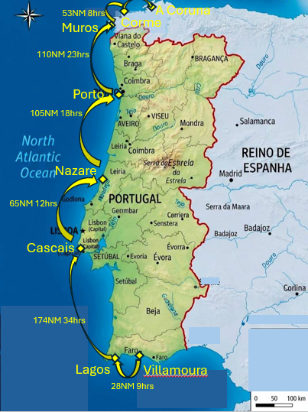

Why deliver Exercise MEDITERRANEAN UBIQUE
- Adventurous sail training is a highly effective way to deliver Adventurous Training Leadership and Resilience training in a relatively cost-effective manner. Until 2025 100 Regt RA had not participated in adventurous sail training for several years; this expedition is the second that the Regt has conducted in as many years, and there is a growing quorum of SP interested in sailing AT. The exercise lead was also Rear Commodore (Offshore) of the RA Yacht Club, and as such was aware of the RAYC legs of Ex MEDITERRANEAN UBIQUE being offered to RA units. Therefore 100 Regt RA taking on a leg was a way to deliver the ALeRT programme to unit personnel, while maintaining momentum to grow experience and promote awareness of sailing within the unit, conducting vital logbook activity for 7 SP looking to progress to the next level; and also supporting the RAYC by taking on a leg that hitherto had not been taken by any unit.
Location
- The Atlantic coast of Portugal and NW Spain offers challenging ocean sailing, with large swells and challenging coastline, particularly in the north, known as the Costa de Morte. Marinas are decent and reasonably priced, especially once away from the touristy Algarve; and there were also a number of stunning anchorages that were used, notably Corme. Despite the fact that the leg took place in August in peak holiday season, flights into Faro, Portugal and out of A Coruna, Spain were not prohibitively expensive. The weather was pleasant – mostly sunny, though with some squalls that made the sailing a lot more adventurous.
Finance
- Funding for the exercise came from a mixture of public and non-public sources; the overall cost of the exercise was £9195.26. Personal contributions were £200 per person (except for the Skipper who had no PC and the sole OR on the boat who paid 60%. A £500 grant was also received from the Ulysses Trust and a £700 grant from the RFCA. The exercise was facilitated within financial PF and NPF budgetary regulations with full breakdown at Annex A.
- Value for Money. Ex MEDITERRANEAN UBIQUE represents VfM, as does adventurous sail training in the round – the main reason being that participants are accommodated on board the vessel and therefore there is usually no accommodation cost. Suitably qualified and experienced personnel were provided from within the unit, so there was no requirement to pay instructors or guides. From a financial perspective, the exercise was delivered at £52.25 pppd, split between £36.84pppd from PF and the £15.41pppd from NPF. Flight prices were high due to the timeframe being peak holiday season and flights being very expensive – they constituted more than half of the overall cost. Discounting travel/transport, the overall cost goes down to £23.23pppd, which represents excellent VfM. An equivalent private sector sail charter and expedition would total £22912. This takes into consideration: transport £487.44pp; boat charter £100 pppd; food £60 pppd; fuel £6.53 pppd; marina fees £3.79 pppd. This equates to £202pppd. Ex MEDITERRANEAN UBIQUE was delivered at 1/4 of this cost.
Publicity
- Publicity obtained by the expedition, including:
  - Gathering media for publicity: Participants all gathered photographs throughout the expedition, which were shared electronically on Google Photos. An article for the unit, Gunner Magazine and also for the Ulysses Trust have been produced.
  - Post-expedition promotion. Post-expedition exploitation is crucial to maximise the positives obtained from the exercise and to promote attendance on future sailing AT activities in 100 Regt.
Experiences and Observations
- Life on board. A journal was kept by Gnr Parsons (week one) and Capt Stuart (week 2), who were the expedition media members. This can be found at Annex B.
- Expedition occurrence. Cracked exhaust flange leak. This was resolved mid-passage by the Skipper Maj Giles and the First Mate Lt Col Edwards, effecting repairs with resin and self-amalgamating tape. While this did not completely prevent further water ingress, it reduced it to a slow trickle, which meant that the leg could continue to A Coruna, when the new crew joining could bring parts out from UK and an engineer could be contracted to make the requisite repair.
- Photographs. A selection of photographs from the expedition can be seen at Annex C.
- ALeRT. Participants have been emailed the ALeRT Student Handbook and encouraged to read it. The following observations were made by exercise participants, when asked to consider and comment on the benefits and value gained from Ex MEDITERRANEAN UBIQUE:
  - From an OR1:
Sailing AT is observation, navigation, sleep deprivation, sailing education, communication, assimilation of information, organisation, sanitation, administration, coordination, collaboration, repairs and renovation; and yes, a little bit of relaxation. It is most certainly not a vacation; this is an austere and challenging environment in which to learn and develop skills, teamwork and watching out for each other, cooking and washing up, cleaning up after the seasick - and also taking the opportunity to draw breath and marvel at the wonder of the star-spread night sky, the excitement of dolphin interactions and the sheer power of the wind and sea.
  - From an OF2:
Alongside the physical skills learnt and developed, Ex Med Ubique exceeded expectations of pushing mental resilience through the requirement to be part of small teams through long periods including at night in difficult sea conditions. This has reminded and refreshed our understanding of the need to train for resilience and perseverance. The need to work well as part of a tight team in close proximity was also very inline with a deployable role in any headquarters.
  - From an OF3:
The opportunity to spend time at sea sailing always helps to bond and foster relationships with fellow service personnel away from the more familiar surroundings of life in 'green kit'. Whilst the key values embedded in us remain, the unfamiliar environment helps to further develop communication, mental resilience, trust and confidence amongst all expedition members
  - From an OF4:
For me the sailing we undertook provided the extra dimension of the orca threat which added an additional degree of complexity and mental stress for the skipper. Working together using sighting reports and current suggested actions, the whole crew were able to work up a plan that sought to minimise chances of contact and reassured the skipper that a range of ideas and solutions had been taken into account and considered for his plan, with all crew collectively bought into his plan.

Recommendations
- Planning. Planning should commence at least 4 months, ideally 6 months, prior to STARTEX. School holiday periods should be avoided if flights are required.
- One-week legs. For Reservists it was very important to provide the opportunity to participate in the exped for just one week, due to constraints with civilian jobs.
- Qualifications. There was not the opportunity to qualify SP as Competent Crew due to lack of Cruising Instructor. It is recommended that an officer within 100 Regt be identified to become a Cruising Instructor, in order to be able to qualify future novice participants as Competent Crew.
- Future sailing AT. The success of Ex MEDITERRANEAN UBIQUE, following on from Ex CANARY UBIQUE in 2025, demonstrates most clearly that similar adventurous sail training activities should be organised for 100 Regt RA, whether this be using the RAYC boats or using the exercises organised by JSASTC, as a cost-effective, challenging and exciting activity that stretches participants and pushes them to the very edge of their ‘comfort zone’, as well as developing cohesion and teamwork in a disparate unit that seldom has the opportunity to draw its personnel together.

JW McCleery
Lt Col
Ex MEDITERRANEAN UBIQUE Leg 10 lead

ANNEXES:

A. Financial breakdown
B. Exped Journal
C. Photographs
Annex A
Ex MEDITERRANEAN UBIQUE Leg 10 PXR
Dated 30 Aug 26

FINANCIAL BREAKDOWN EXERCISE CANARY UBIQUE

Income

Ser | Source | Amount (£) | Remarks
1 | 100 Regt RA travel budget | 5027.08 | Flights and rail
2 | CILOR | 1051.63
3 | Personal Contributions | 1916.55 | £200pp except for skipper (no PC) and the only OR (paid 60%)
4 | Ulysses Trust | 500
5 | RFCA | 700
 | TOTAL | 9195.26

Expenditure

Ser | Source | Amount (£) | Remarks
1 | Yacht charter | 600
2 | Travel – flights | 4727.48
3 | Travel – rail | 299.60
4 | Transfers – taxis/coach | 334.71
5 | Fuel | 685.25
6 | Sundries | 72.19
7 | Food/non-alcoholic drink | 2078.21
8 | Marina fees | 397.82
 | TOTAL | 9195.26 | £835.93 pp (of which £487.44 pp was travel)

Annex B
Ex MEDITERRANEAN UBIQUE Leg 10 PXR
Dated 30 Aug 26

100 REGT RA SAILING LOG - EX MEDITERRANEAN UBIQUE Leg 10
Introduction.
100 Regt RA undertook an overseas AT offshore sail training expedition from Villamoura to A Coruna up the Atlantic coast of the Iberian Peninsula between Sat 8 – Sat 22 Aug 26, involving 11 Army Reservists. The expedition took place on St Barbara V, a 42-foot Rustler ocean-going yacht provided by the Royal Artillery Yacht Club (RAYC) under the Exercise coordination of Lt Col Jon McCleery and skippered by Maj Rob Giles. This expedition provided a breadth of opportunities for new and experienced sailors alike, allowing for those with existing qualifications to score valuable logbook entries to prepare them for subsequent qualifications.
Inevitably there are costs involved with the organisation of such activities – and 100 Regt is most grateful to the Ulysses Trust and RFCA for the grants towards running the expedition; without them the service participants would have to have dug more deeply into their own pockets, which goes against the spirit of what challenging adventurous training aims to achieve.

Saturday 8th August: The Crew of the St Barbara V arrived in two packs into Villamoura with Skipper Maj Rob Giles, Lt Col Jim Edwards, Capt Josh Moultire, and Gnr Lloyd Parsons being the first on sight to collect keys and arrive into the very impressive Villamoura Marina. A quick division of labour saw a shopping party assembled in order to conduct the vital victualling task and restock the galley, leaving a ships party to complete the preparation and await the arrival of our colleagues. Around 1930hrs, our first four are joined by Maj Charlie Calderwood, Maj Owen Brown and Capt Tim Benson, making our full ship’s company of 7. An evening of briefings, routes and options, accompanied by tapas and a light picking dinner formed our first night on board.

Sunday 9th August: Villamoura-Lagos. 28NM. 9 hrs.
The St Barbara V slipped from Villamoura Harbour early to make way for Lagos as our first port of call. The morning was spent with some essential basic refresher training for those experienced and some knowledge building introduction training to those new to the water. A good period of time was spent recapturing “Davey Buoy” as the crew got up to speed with man overboard drills, mastering quick coordination and skilful handling of our 42ft yacht. As she made her way into Lagos, we were met with spectators and waves as the marina footbridge is raised to allow our masts to pass through and enter the marina, providing a semi-symbolic grand welcome before being masterfully brought alongside and then quickly put to bed for an evening.

Monday 10th August: Lagos-Cascais. 174NM. 34hrs, 10 night hrs.
After a brief restock on Monday morning, she slipped from her berth in Lagos marina, exited between the raised salute of the marina footbridge, and then pushed north through the day and night in 4 hour watches, to travel a total of 174 nautical miles through choppy seas. Her crew were tested as peak followed trough in each wave, and broadside waves made being below deck all the more eventful and bruising. Thankfully, and also tragically, the only casualty of those very rough seas was a freshly brewed pot of ground coffee. The St Barbara V spends a fair amount of time out of Portsmouth and the UK, and her duties and mileage are admirable, but the leg of this journey would highlight the wear and tear that can happen aboard such a yacht, as two cracks in the flange surrounding an exhaust mount were discovered and she was taking on water in a rather alarming fashion. Monday night celestial showers provided a captivating night show to accompany our frequent bilge-pumping to counteract the effects of the cracked flange, after a fine fill of Pasta Carbonara provided by the Skipper.

Tuesday 11th August: The morning change over of watches was accompanied by a pod of junior dolphins who came to greet the incoming watch. After a rough night of testing the limits of sleeping down below, the new watch were no doubt happy to be above deck, and a well worked night watch were happy to hand over and slip into their bunks. Calmer waters would ensue as the day went on, and the St Barbara V arrived into Cascais. An opportunity to get ashore for some stability and a shower, followed by a medley of tapas for an evening dinner.

Wednesday 12th August: Wednesday would prove the compounded wear on Santa Barbara after years at sea as two fractures to the hull around an exhaust fitting had appeared during the long leg. The benefit of three officers of the Royal Engineers on board would also prove their worth as the makeshift “Robot Wars Sappers” got to work on unpacking tools and kit in order to remove, degrease, sand, prep, fit and glue in order to make running repairs to the St Barbara as she awaits a more permanent repair in due course. The ability for our Skipper to fit in a lazarette locker, work and repair on the ship, whilst baking in high temperatures was admirable, although not enviable from the wider crew. Wednesday evening the crew anchored outside of the marina, with Solar Eclipse inbound and steak night on the menu from the galley.

Thursday 13th August: Cascais-Nazare. 65NM. 12hrs.
Thursday AM, the morning watch would up anchor circa 06.40 hrs and make the push north staying closer to the coastline due to running repairs and increased risk of Orcas. The early watch were immediately met with 30knt winds requiring a double reef, a lot of spray, and a fair amount of keel angle. After a few hours, wind speeds had returned to a more favourable 18knts and the crew would continue to push north into the wind, under motor and sail due to the wind being right on the nose. These hours would be spent positively ID'ing lobster pots to ensure that we wouldn't snag a line in the propeller. This essentially made for hours and hours of weaving, ID'ing, calling out, and curving round as we mitigated the maritime minefield of lobster pots and fishing lines that hug the Portuguese coast, before arriving into Nazaré.

Friday 14th August: Nazare-Porto. 105NM. 18hrs. 10 night hrs.
A later start to the final leg, which would see the crew make the final push north from Nazaré, up toward Leixões, just outside of Porto. Since leaving Cascais, the weather had never quite recovered and the crew had largely sailed through the grey and slightly drab weather, which showed no real sign of relenting in our final passage. Our final sea states were mixed, with periods of undulating peaks and troughs, accompanied by large lashings of spray occasionally greeting the helm as if more akin to a comedy sketch, observed from those in the cockpit taking cover behind the spray deck. A long period, back into our 4 hour watch scheme saw the St Barbara V motor sail throughout the day, evening, into the night and into the early hours of the morning, with the wind frustratingly and stubbornly coming from exactly the direction in which we needed to be headed.

Saturday 15th August: After a good overnight leg, we arrived into Leixões early, passing a vessel coming out of the marina in the early hours, that we had not seen since Cascais. Our trip north had been relatively solitary, save the crossing of shipping vessels like giants in the distance, or the darting of occasional smaller fishing vessels working the coast. Upon coming into the marina, St Barbara V and her ship’s company had completed 372 nautical miles, providing some challenging overnight sails, some exceptional scenery (including the Celestial Shower and Solar Eclipse), as well as some absolute culinary delights from the galley. A solid day’s work cleaned her down, reorganised her kit and provided a period for the majority of the crew, who would depart the following day, to pack and get themselves in order. A final farewell evening meal was shared by the crew who took to the Matosinhos municipal fish market as a reacquaintance with terra firma, before departing the following morning, with Skipper Rob Giles staying aboard, accompanied by the purser Josh Moultrie who would remain to welcome the inbound crew change on Sunday 16th of August.

Sunday 16th August: With the departure of the previous crew, came the arrival of the crew of Leg 10, pt.2. Lt Col Jon McCleery, Majs Andrew ‘Nobby’ Clarke and Rob Hoey, and Capt Will Stuart had landed. Straight from Porto Airport to the marina to drop off kit, then to the local supermercado to pick up much needed supplies for the week ahead. The newcomers were given the introduction to St Barbara by the skipper and proceeded to make themselves at home. Dinner, a wander into town and a relatively early night set the crew up for the coming sail.

Monday 17th August: Porto-Muros. 110NM. 23hrs. 10 night hrs.
A 0700 Reveille saw the crew up on deck and prepping the yacht for her voyage. Rob Hoey quickly scaling the mast in the bosun’s chair to inspect every inch of the craft from above and take a close look at the rigging before the next long stint. Foul weather kit dished out, route planned, water topped up and personal kit stowed, St Barbara slipped her moorings at 1100 sharp, making her way out to the open waters West of Porto. The crew quickly found their sea legs and were given the opportunity to practise at the helm in the relative shelter of the sea walls before pushing out. With winds coming from the North (the desired direction of travel), and a schedule to meet, the St Barbara and her crew had the mainsail up with the motor chugging away, pushing into the Atlantic. Man-overboard drills complete, all crew having had opportunity to helm and work the sheets, we split into watches and started our four-on, four-off rotation. As the day pushed on, the weather deteriorated, the waves swelled and the St Barbara splashed on into the dusk.

Tuesday 18th August: Sailing through the night in sea state five proved a challenge the new crew thrived in. At times visibility was as low as to the bow of the boat, the helmsman relying on his navigation equipment and glimpses of lights in the distance, unable to see the next wave before it crashed over St Barbara. The going was tough, the watch thoroughly soaked - although strangely only one of the watches seemed to suffer from a constant drenching, while the other remained relatively dry - the watches rotated throughout the night, and with the dawn came the settling of the sea. More importantly it came with the settling of the stomachs of a couple of the crew, who had fallen foul of Nelson’s personal affliction (No, not losing an eye and an arm). The crew pushed on to Muros harbour, refuelling before settling in for the afternoon.

Wednesday 19th August: Muros-Corme. 53NM. 8hrs.
Slipping the moorings before first light, we pushed back out to the Atlantic to watch the sun rise over the mountainous terrain of Spain to our East. Raising both sails, and making good speed, the crew continued to push North. The plan being to make way to Corme, where anchorage would be found in the sheltered bay. On the journey to our stopping point, we were joined by other seafarers, multiple pods of dolphins, Portuguese man-o-war, sharks, and critically no orcas. A threat to those sailing from Gibraltar to the North of Spain, orcas have been attacking boats’ rudders and have even sunk a few (7 in the past 6 years). Breaking into our watches once again, we pushed on Northward and made our destination in the early afternoon. After dropping anchor in the most stunning sheltered bay and securing the boat, we packed our kit into dry bags and swam ashore for a wander around the town of Corme, which did not have a great deal to offer besides its lovely bay. A bolognese for dinner back on the boat and the crew battened down for a night at anchor.

Thursday 20th August: Corme-A Coruna. 39NM. 7hrs.
The final day of sailing and the last dash to our destination - A Coruña. A final early start saw us slip silently out of the bay that had been home for 19 hours and the last push to around the NW tip of the Iberian peninsula and eastwards to A Coruna. We were once again joined by a plethora of marine life, other craft heading the same way as us, and once again critically no Orcas. Throughout the journey it had been a choice to sail close enough to shore so as to best avoid the playground of the killer whales (reportedly there is little chance of an ‘interaction’ in water shallower than 20m, while dodging the lobster pots that are ubiquitous closer to land, and also balancing concerns about that treacherous rocky coastline, which goes under the name of Costa de Morte. Thus there was a team effort all around with heads on a swivel and eyes on the depth gauge. At 1215, the impressive Tower of Hercules lighthouse was spotted off the starboard bow, the marker to the entrance of A Coruña harbour. We sailed past the Roman lighthouse, soaking in the heat of the day and the gratification of a job well done, past the Medieval fort - laid (unsuccessfully) siege to by Sir Francis Drake and the English Armada in 1589 - and into harbour for a well deserved stop. Now the hard work began. The Yacht was to be refuelled, fully scrubbed down, all kit and equipment washed and dried, food sorted through, water replenished, sails stowed and ropes coiled, as she was to be ready for the 104 Regt crew arriving in two days’ time. With preparations complete, the crew were taken for an historic tour of A Coruña, presided over by Lt Col Jon McCleery, covering the failure of the English Armada, and also the Battle of Corunna in 1809. Visiting the historic ramparts of the city, the fortress and grave of Sir John Moore - who fell enabling his troops to withdraw to sea and fight another day under Wellington against the scourge of Napoleon - we were truly in awe of the city we had sailed in to. Refreshments in a local bar saw out the end of the day, beneath the statue of Maria Pita, the heroine who saw off Drake.

Friday 21st August: The last day on the boat and the final opportunity to ensure St Barbara was in tip top shape. The crew, having removed all floor plates and scraped clean every inch of the inside of the boat, broke off into packets and went to explore the remaining parts of A Coruña, catching up for an team last supper in the evening. A fitting end to a week of, at times, rather challenging conditions and feeling that a great team had been forged.

Saturday 22nd August: Packed up and ready to move out, goodbyes said to our neighbours in the marina - Particularly FUBAR and SNAFU, two French wire haired pointers, on their way North for four months, along with Gaia their ships cat and their two crew - we made way to a local cafe for one last coffee before heading to the airport and our return home.
Summary
Sailing has started to gain traction as a valuable AT and sport activity in 100 Regt which can stretch and challenge personnel, as well as providing wonderful opportunities for teams to get to know each other well and learn how to work together. Observation, navigation, sleep deprivation, sailing education, communication, assimilation of information, organisation, sanitation, administration, coordination, collaboration, repairs and renovation; and yes, a little bit of relaxation. But this was most certainly not a vacation; it was an austere and challenging environment in which to learn and develop skills, teamwork and watching out for each other, cleaning up after the seasick, and also the opportunity to draw breath and marvel at the wonder of the star-spread night sky, the excitement of dolphin interactions and the sheer power of the wind and sea. Granted, the wind was not our friend during this expedition, as it nearly always blew directly from the direction we needed to head to, and with a schedule to stick to we did not have the luxury of time to be able to take long beats into the wind and make slow progress up the Portuguese coast; but that’s sailing, and it is no reason not to go back onto the water to get more experience. Ultimately in 100 Regt we aim to generate a pool of experienced Yachtmasters who can lead adventurous sail training for troops across the military. Ex MEDITERRANEAN UBIQUE has enabled progress along that line of aspiration.

Annex C
Ex MEDITERRANEAN UBIQUE Leg 10 PXR
Dated 30 Aug 26

Ex MEDITERRANEAN UBIQUE Leg 10 PHOTOGRAPHS

Figure 1: St Barbara V – a Rustler 42 yacht, the RA Yacht Club flagship and ‘home’ for 2 weeks.
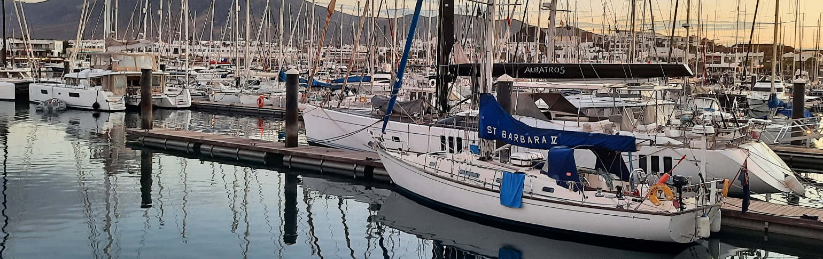
Figure 2: Heeled over and making good way in the breeze. During the day temperatures were in the high 20s, allowing for shorts/t-shirts beneath the obligatory lifejackets
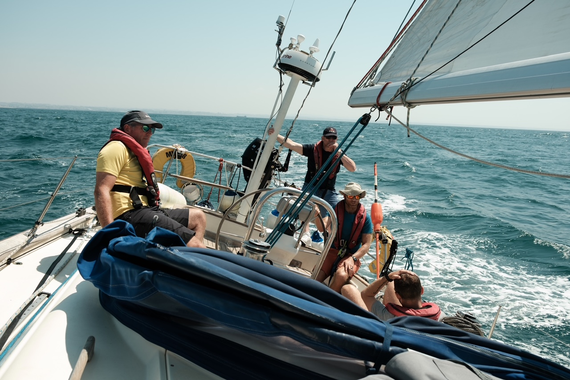

Figure 3: Dawn breaking after a long night passage. Lower temperatures and spray from the pitching of the boat meant warm and foul-weather gear was necessary. Morale remained high, despite the lack of sleep and sea-sickness. The Skipper, Maj Rob Giles, is pointing out something to the mate Lt Col Jon McCleery – or perhaps taking a selfie?
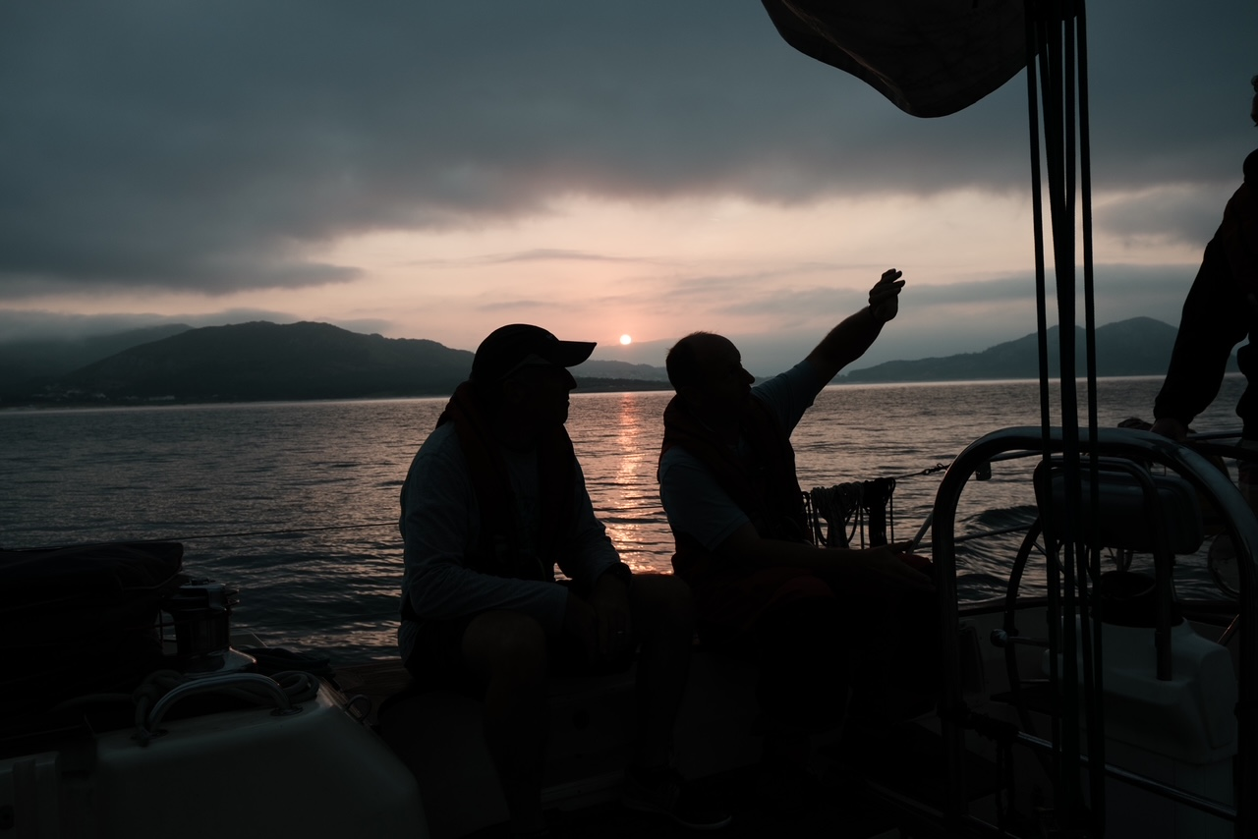

Figure 4: Nature provided beautiful displays. Lagos marina at sunrise:
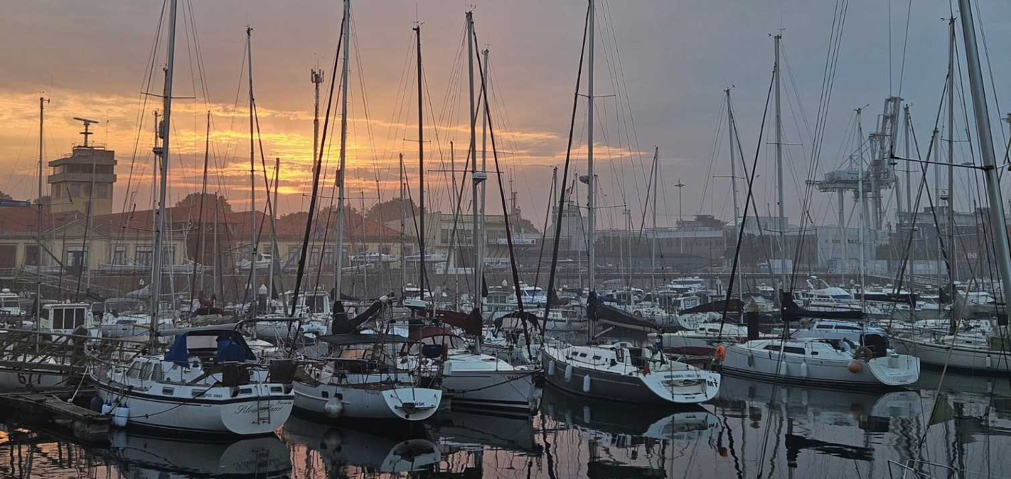

Figure 5: ….. or the powerful splash of the Atlantic creating a kaleidoscopic sunset.
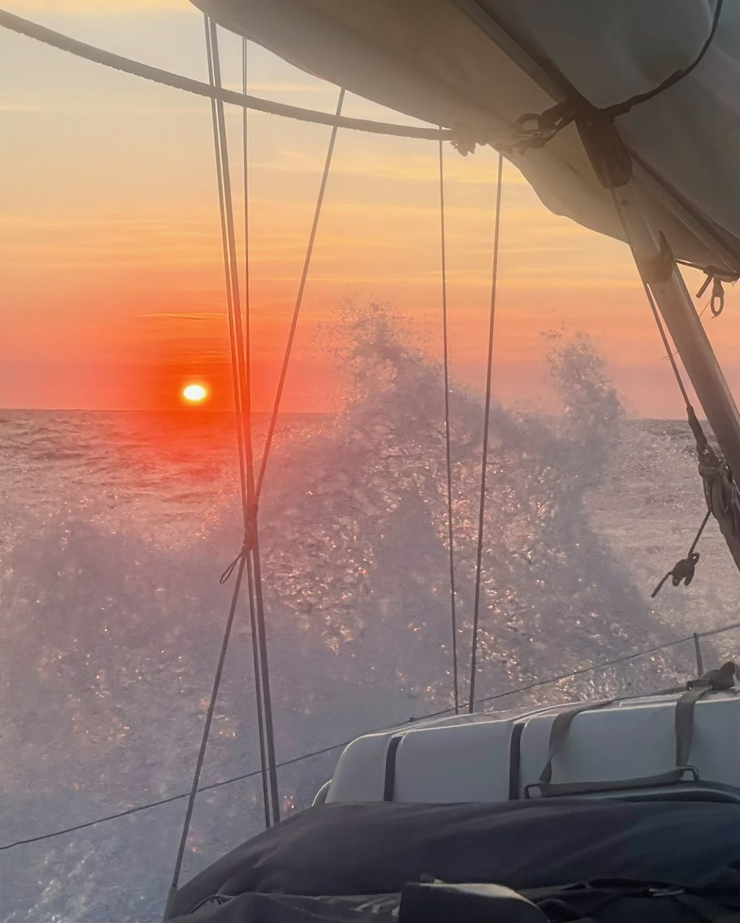

Figure 6: Flags are important in the military, and due to a broken pole the Gunner Ensign was flown high up from the backstays.
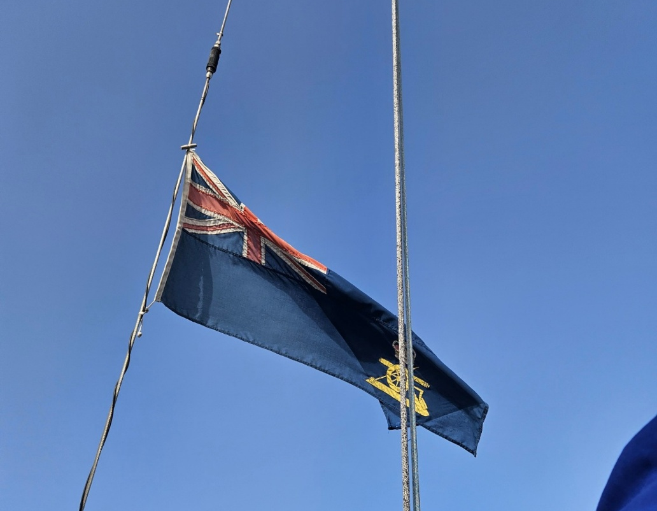

Figure 7: Getting the ensign attached to the backstay was quite an acrobatic feat for Maj Rob Hoey.
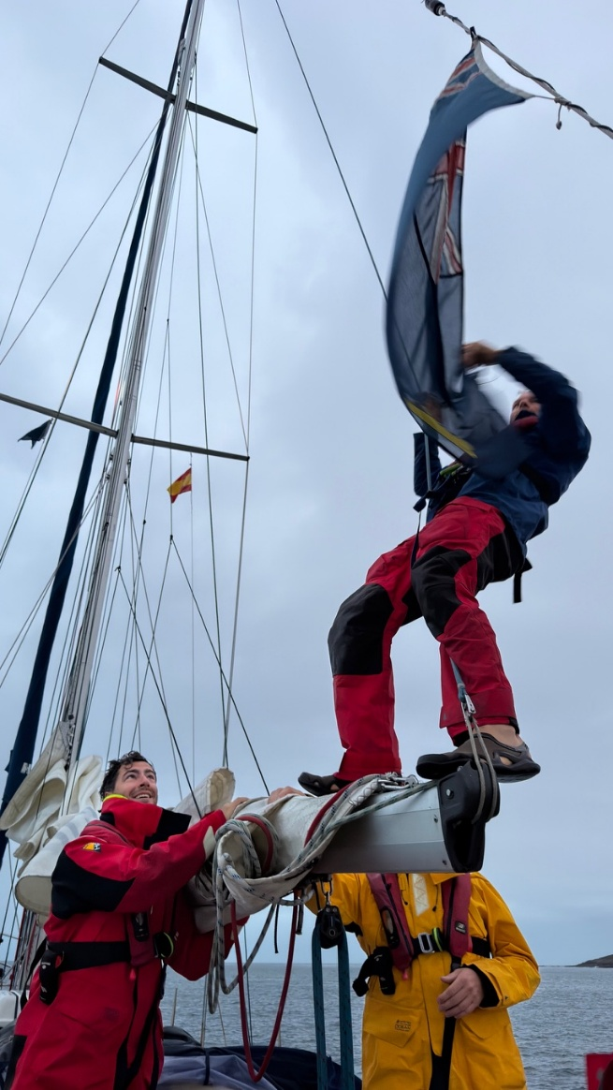
Figure 8: Gnr Lloyd Parsons and Capt Tim Benson from 255 TACP Bty proudly displaying their Bty flag.
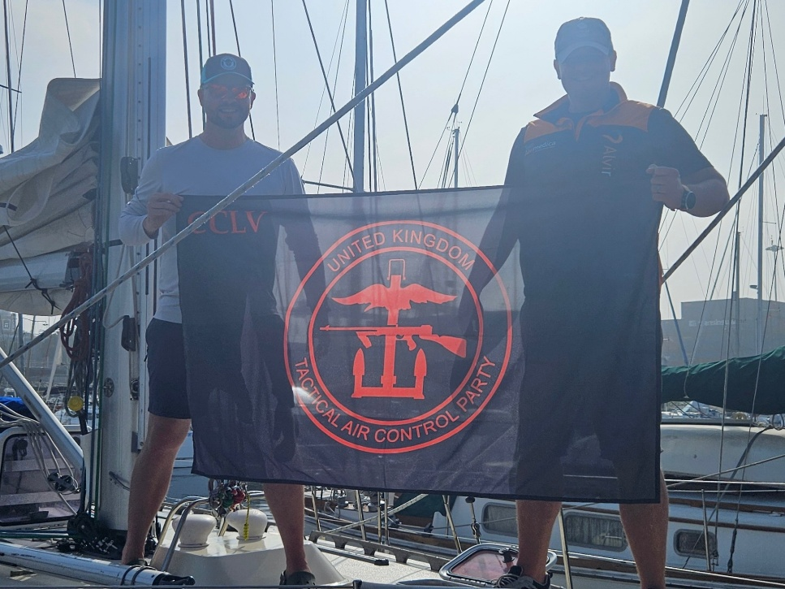

Figure 9: Grateful for sponsorship from the Ulysses Trust, a drone’s view of the crew with the UT flag on the bow
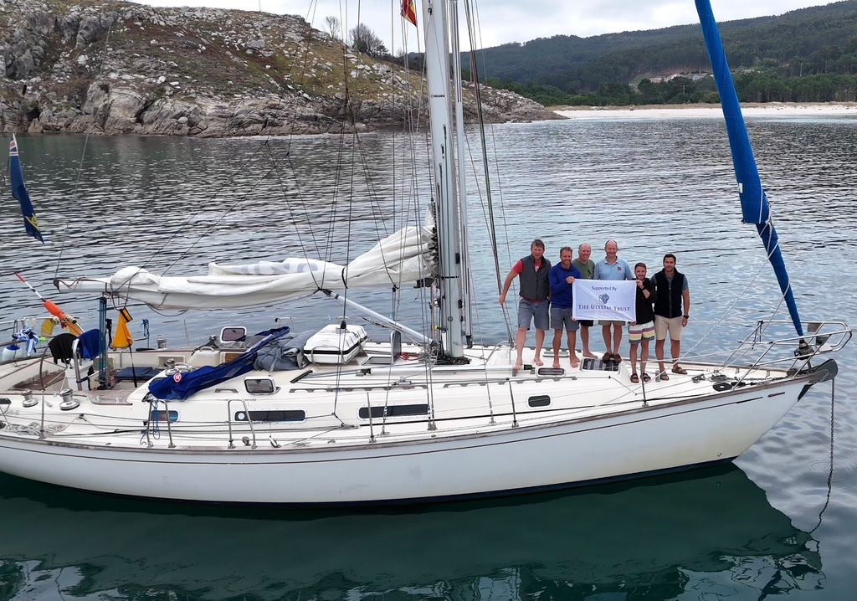

Figure 10: Everybody got the chance to take the wheel – Capt Josh Moultrie was a newcomer to sailing, but loved being on the helm. During the on-watch everyone would spend 20 mins at the helm and then change over.
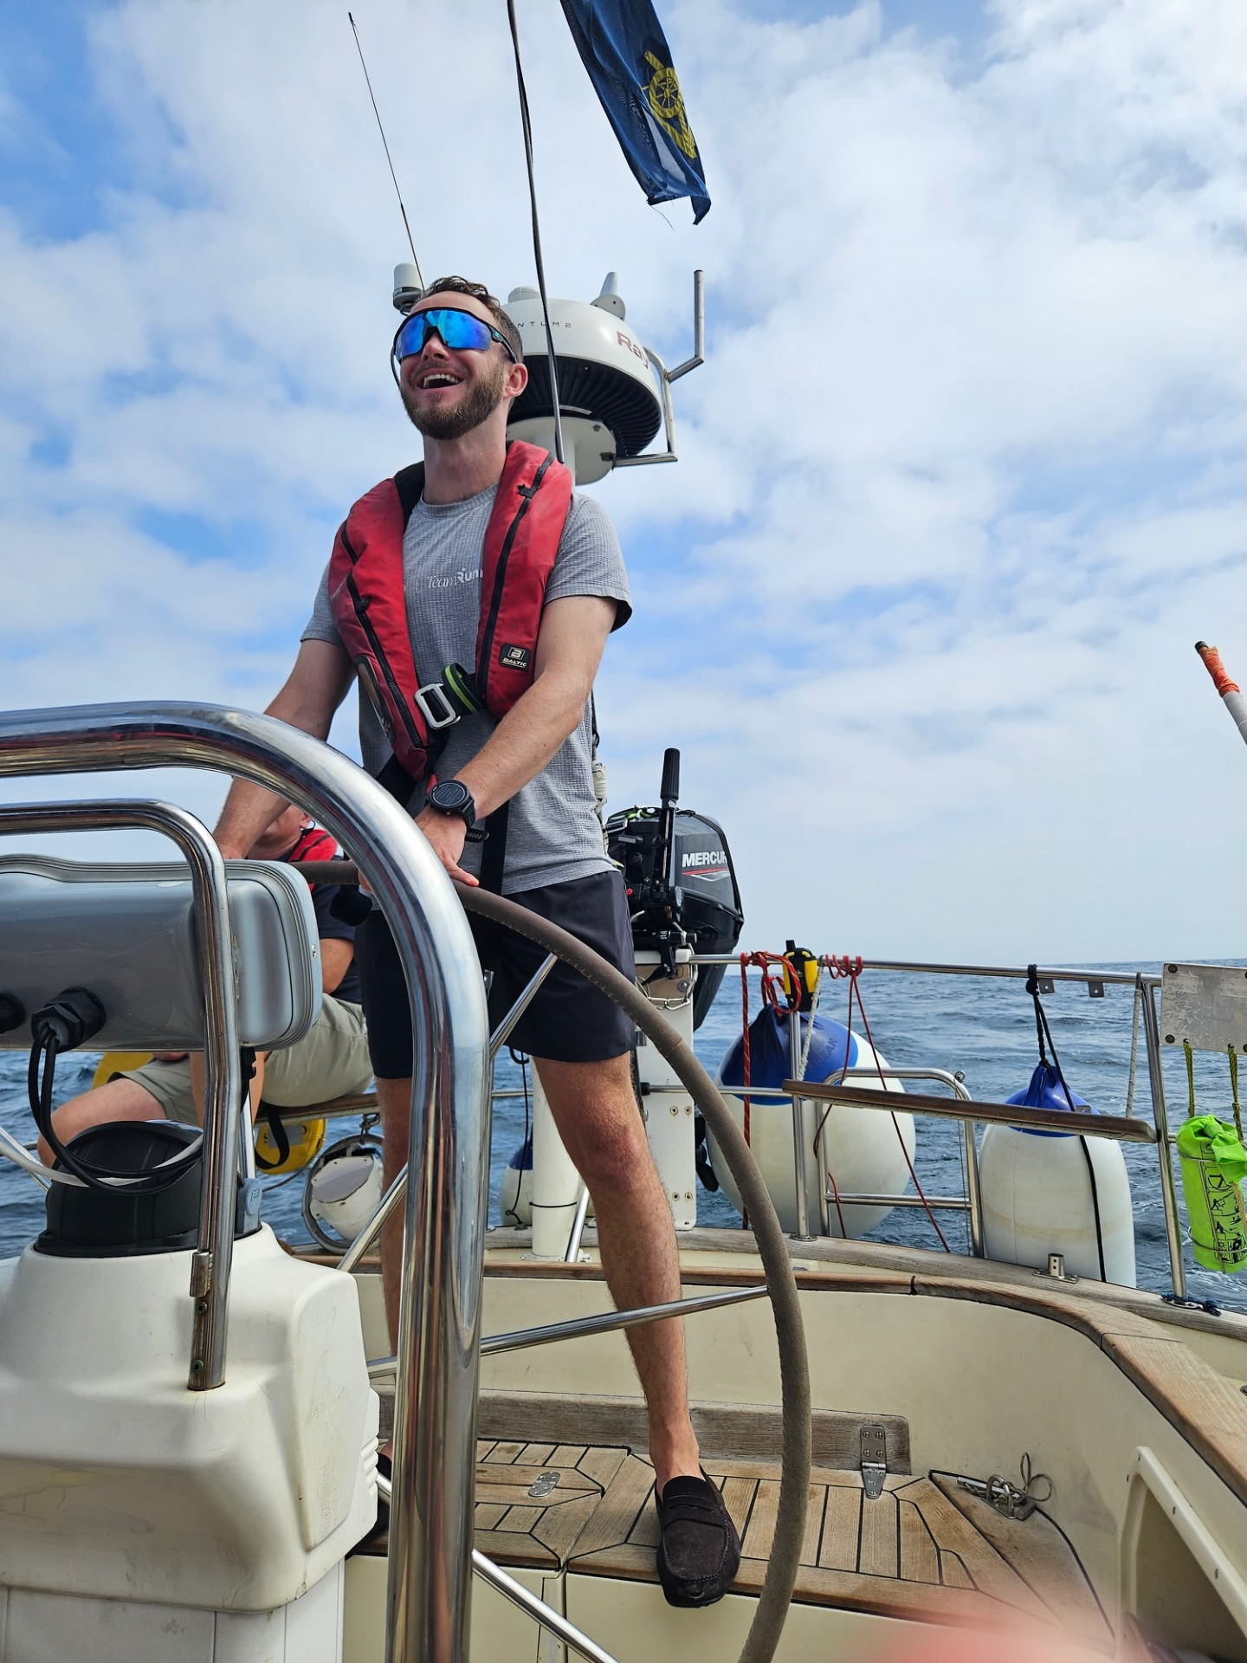
Figure 11: There were some situations when the more seasoned sailors would have to take over the helm – here Lt Col Jim Edwards has just guided St Barbara through the Lagos Harbour drawbridge, with Capt Tim Benson showing his admiration in a typical TACP way.
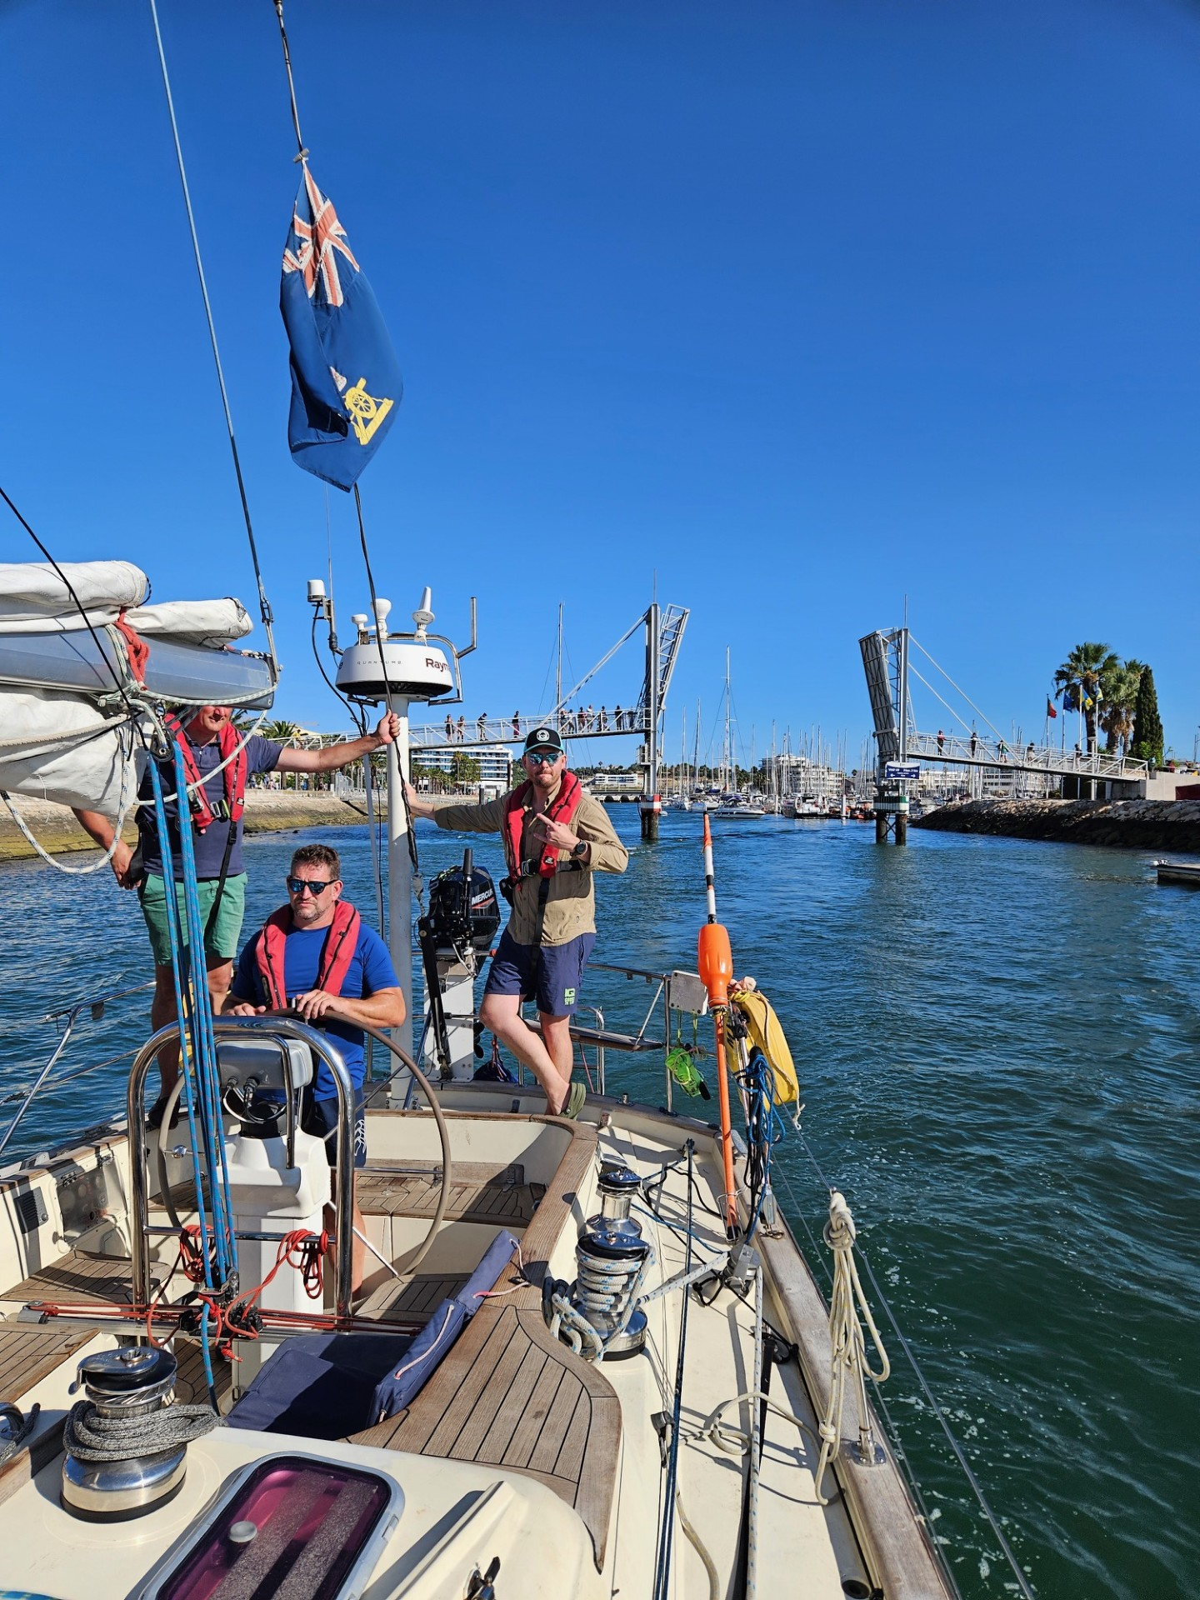
Figure 12: Sometimes we pulled into land alongside in marinas, and sometimes we anchored in a sheltered cove, such as this beautiful bay at Corme.
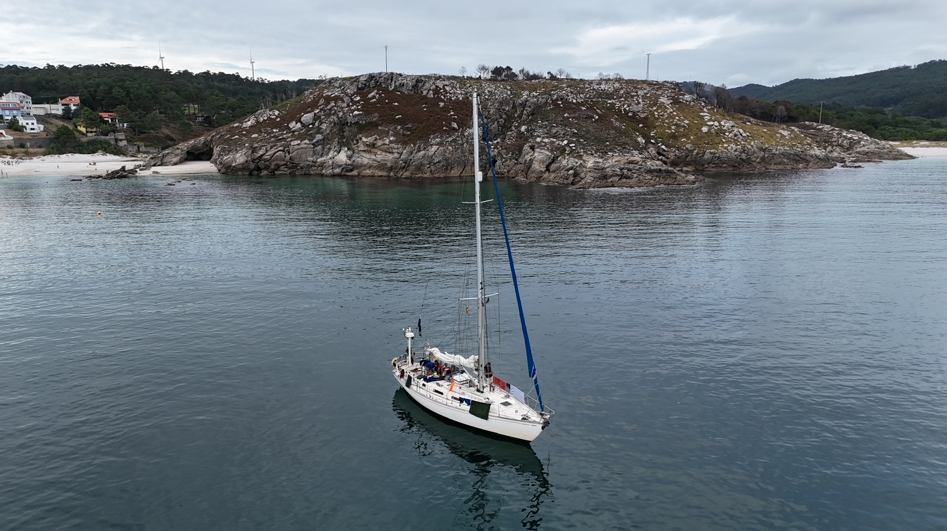
Figure 13: Maj Owen Brown fighting with the main sheet. Capt Josh Moultrie on the helm while Capt Tim Benson and Maj Charlie Calderwood kept a lookout for lobsterpots and orcas.
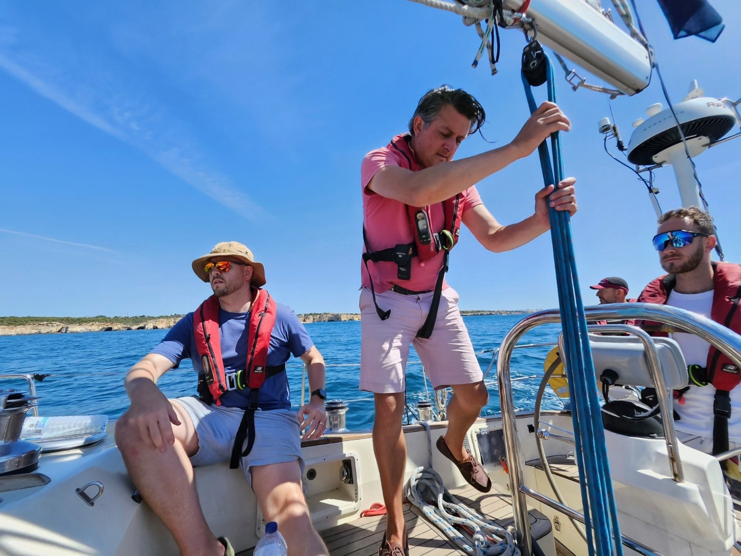
Figure 14: As the most nimble crew member, Maj Rob Hoey was volunteered to go up the mast in the Bosun’s chair to carry out a rigging check (he was also the most experienced crew member, so that also help determine that he be the high-flyer).
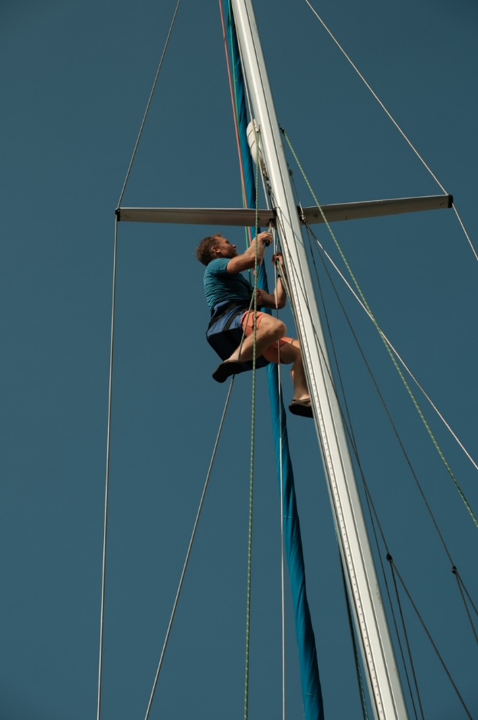

Figure 15: Dolphin interactions were frequent and invariably gleeful. Fortunately their larger orca cousins did not appear.
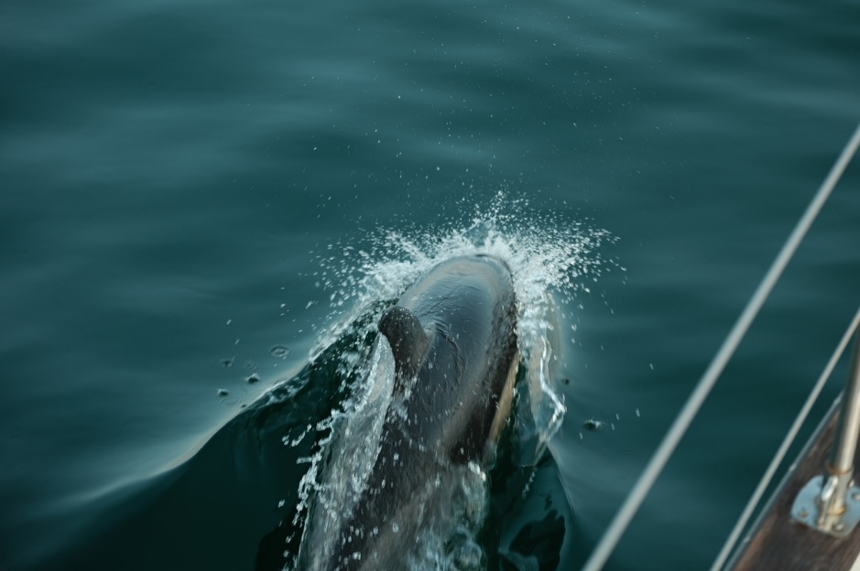
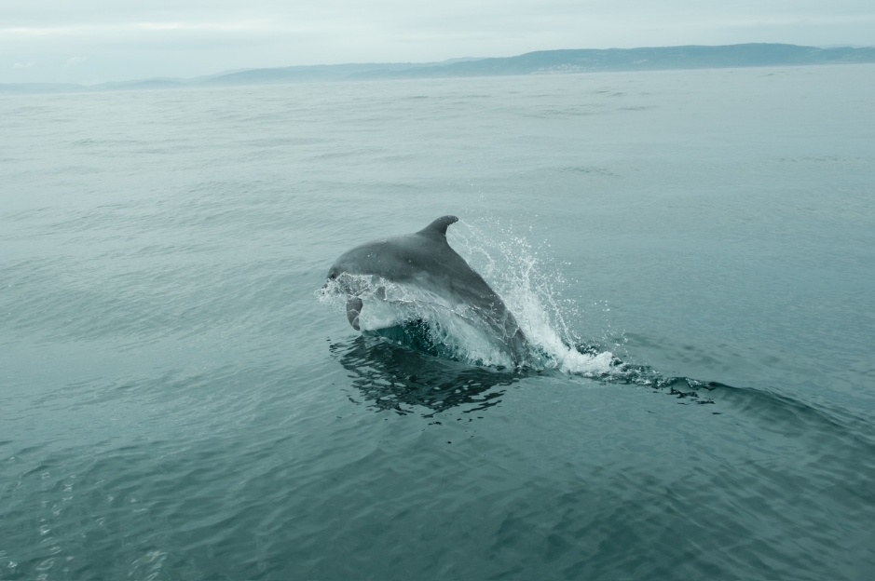
Figure 16: On the medieval walls of A Coruna, which saved the city from the rampaging English Armada in 1589. On the final day Lt Col Jon McCleery delivered a short battlefield tour of this event, and also of the 1809 Battle of Corunnay. Unfortunately the Sapper couldn’t resist sitting on the Colours, to the great chagrin of the Gunners.
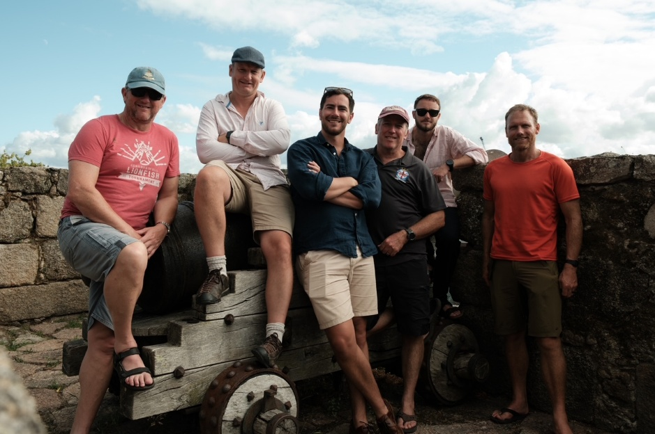

Equivalent to Ex MU transport costs
Charter price based on internet quotes for Vilamoura-based yachts of similar size
Estimation based on eating out rather than self-catering (iaw CILOR regulations)
Equivalent to fuel used on Ex MU
Equivalent to marina fees for Ex MU

